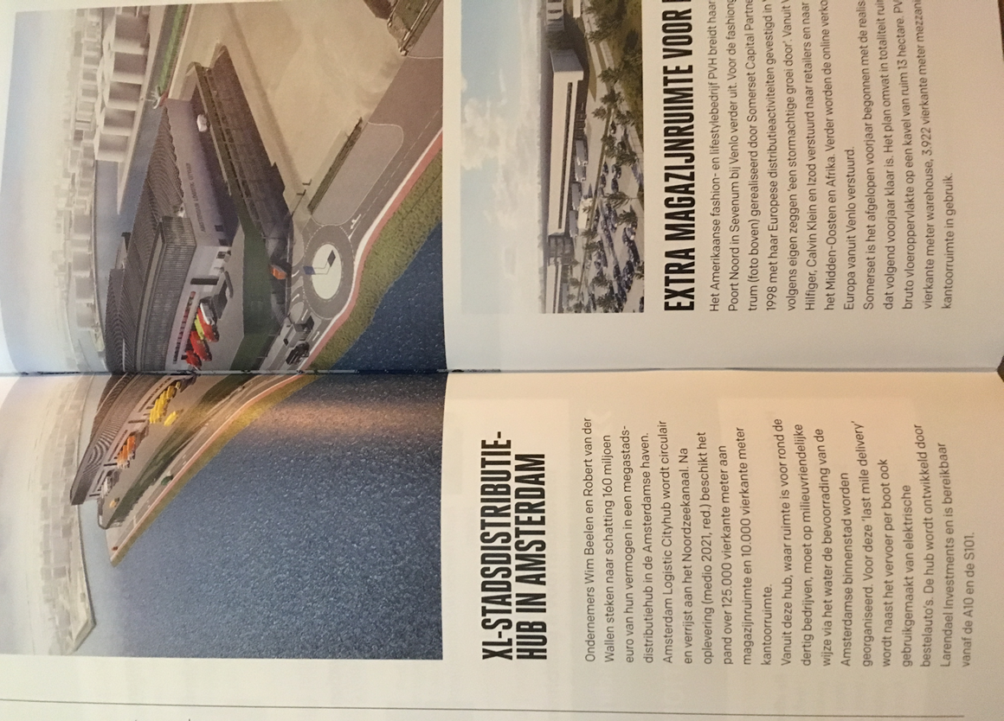

Short message in ‘Logistiek’, September 2019:

Wim Beelen and Robert van der Wallen invest 160million euro in a logistics HUB in the Amsterdam Habour area. From this HUB the centre of Amsterdam will be delivered with smaller ‘electric’ trucks. A very good solution to reach the centre of Amsterdam more efficient and more sustainable. Of course the HUB itself will be build circulair. A very interesting project! .